
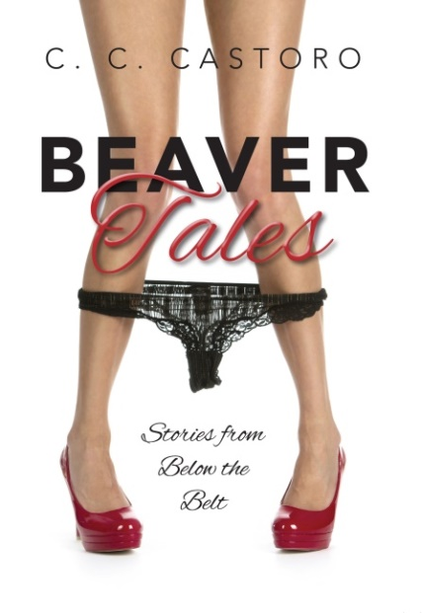
Mill City Press
Hardcover: $19.99
978-1-63413-970-0
Page Count: 97
Release Date: 5/10/16
www.beavertalesbook.com

FOR IMMEDIATE RELEASE

Cheeky New Release Reveals Risqué Spa Secrets

Philadelphia, Pennsylvania (May 10, 2016) – Readers will be enthralled by this bold and brazen new tell-all Beaver Tales; Stories from Below the Belt by sought after spa esthetician C.C. Castoro. This wax-a–nista virtuoso bares it all with steamy details about her clients’ intimate body waxing experiences. Men and women alike will be chirping and tweeting about these saucy vignettes at happy hours, dinner parties, on date nights, girls and guys night out, cigar clubs, coffee bars, the gym, and of course, the salon and spa!

Meet the cougar on the prowl, the young collegiate who goes commando, and a silver spoon country club gent looking for a happy ending; there isn’t anything ordinary about the clients in Beaver Tales. Eager readers will gobble up these true tales and be left begging for more.

This entertaining and cheeky page-turner promises to be a book readers will enjoy over and over again. There will be no shortage of conversation about this daring tell-all, once it hits the stands on May 10, 2016. The best part might just be the last chapter, where C.C. turns up the heat by revealing her own elusive selfie. There will be no doubt of what lies below the belt after reading Beaver Tales!
About the Author

C.C Castoro’s journey into skin care began several years ago during her many business trips when she frequented day spas to relieve the stressful demands of her bi-coastal career. C. C.’s personal experiences at spas she had fallen in love with left her obsessed with learning the art of Brazilian and body waxing. After years of trains, planes, and automobiles, she left the corporate world to re-invent herself as an Esthetician.

C.C. launched her career by continuing her training in advanced esthetics while working for a boutique spa. Her success was soon followed by a métier at a prominent day spa. C.C.’s techniques and client centered approach helped her to build special relationships with clients who would tell all behind her closed door. Her stories were the topic of many happy hours where friends implored her to tell more. It was at this point she began to journal these anecdotes that would eventually become Beaver Tales.

